
Meet our new Parent
Parent Support Worker
Support Worker Christine
Eland. Christine is here
to help parents with
things such as forms,
housing and community
sign posting. Christine is
available every Monday
and Friday morning at school.
Supporting your child
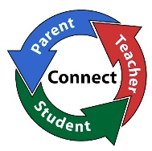


At holy Rosary we believe that Parents and teachers should work together as a team, towards creating the best possible learning environment for our children.
Please be sure to watch your child’s curriculum video in order to best support them with their learning this year! Each teacher has uploaded this to the class Showbie page.
Please complete all homework set on Showbie each evening. This will build on class work and allow you to support and become involved in your child’s learning.
Parent Teacher meetings will take place on 8th December this year. Please keep this date free.



It’s fantastic to have violin and brass lessons starting back in school again this year. Wishing all the pupils involved a great year ahead with lots of practising too!!
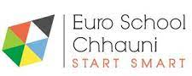

Connecting Classrooms

N.Ireland Nepal
We have got off to a fantastic start this year with our new Connecting Classrooms project. Staff connected via Zoom with our NI/Nepalese cluster group of 16 schools, before planning pupil projects with our partner school ‘Eurokids, Kathmandu’.
A number of our classes have been working very hard on different projects, along with children from Eurokids. Our classes took part in virtual lessons over a 3-day period.
Mr Sinclair’s P6 class completed their collaboration titled ‘Child Rights’.
Mrs Moffett’s P5 class completed their collaboration titled ‘Digital Literacy’.
Mrs McCartan’s P4 class completed their collaboration titled ‘Building my Character’.

The overall project will focus on the Global Sustainable Development Goals and is called ‘Creating Compassionate Citizens’.
Our next session will be a whole school Art and Wellbeing session. All classes will connect virtually with our partner school and an artist on the 8th and 9th November. Please make sure you have given permission for your child to take part, as we wouldn’t want them missing out!



School Counselling Service

Let us know if you feel your child would benefit from our school counselling service.
Extended Schools

Term 1 Literacy and Numeracy P7 classes:
Extended Schools

Well done to all our P7s who have been taking part in the extra Literacy and Numeracy classes every week. They have been working really hard and having a lot of fun at the same time, by the looks of it! A big thanks to the teachers who have made these lessons fun and interactive for all! These classes will run up to Thursday 18th November. We hope they will be helpful for the pupils doing the transfer test in November and wish them every success for the tests.

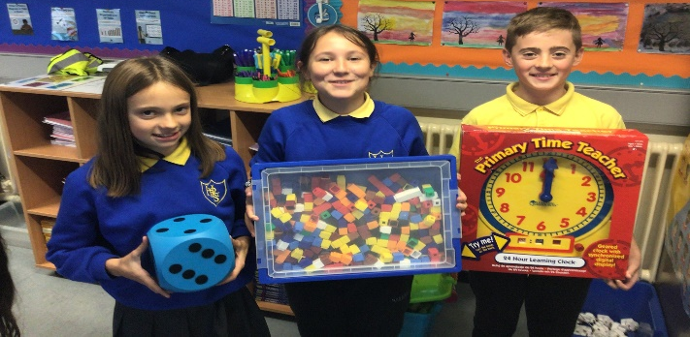

Extra classes for P4 children will begin in January, classes for P5 pupils will start after February mid-term and P6 classes will start in March.
Irish Dancing

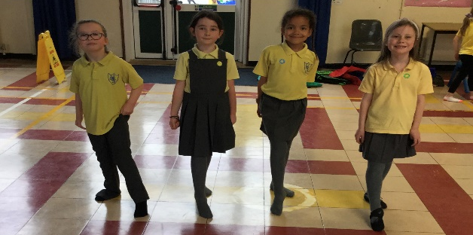

P4 Irish Dancing club is taking place this term. P5 Irish Dancing will begin in January and P6/7 in April.

