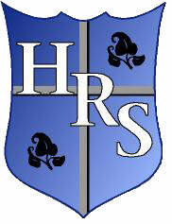
Holy Rosary Primary School
December 2019 - Newsletter No.2
Dates for Your Diary

- Wednesday 18th December at 1.15 pm in the hall - P6 Shared Education Celebration day.
- Friday 20th December - School closes for Christmas holidays at 12pm no dinners or after-schools. Non-Uniform Day.
- Tuesday 7th January – School re-opens for Term II
- Wednesday 5th February 11 am – P7 Confirmation
- Calendar Update – Friday 14th February school will be open for children. School will now be closed on Friday 13th March for staff training.

Christmas Bazaar
Thank-you for your very generous support for our recent Christmas Bazaar. The Bazaar raised an amazing £1936.24 which will go towards the HSA’s fundraising targets for this year. A special thank-you to all the local businesses and organisations listed below who donated prizes for the raffle.

The Learning Tree, Michelle’s Fresh Fruit and Veg, Tesco, Dunnes Stores, Co-op, Cowzers Pharmacy, Oriel Pharmacy, Harlow and Gold, Riah Hair & Beauty, Beauty by Danielle, Queens PEC, Movie House Cinemas, Pavilion, Errigle Inn, Macau Restaurant, McCulloughs, Nicos, Kaffe O, Bread & Banjo, Sunray Home Bakery (Amanda Hardy), Tartine – Distillers Arms, Cutting Edge Barbers, Sainsbury’s, Mace, Ormeau Pharmacy, Molton Brown, The Parador, The Hatfield, L’Etoile du Nord, The First Floor Bistro, Shed, Soul Food Café, Al Gelato, Graffitti, Hungry Hound, Bredagh GAA Club, Advance Waxing Clinic, Holland & Barrett, Al Gelato, RGB, Errigle Inn, Roar and Explore, Anytime Fitness, Crowzer’s, District, McCullough’s, Wine Company, Medicare Chemist, Subway, Tigger Happy, Springsteens, Podium, Café Nero, Nico, Ulster Rugby, Hot Wheels, General Merchants, Shed, Northern Lights, Bia Rebel, Waterfront Hall, Let’s Go Hydro, Café Conor, Centra, Lidl, Oscar’s Barbers, Coffee Maker.
Thank-You
We would like to say a big thank-you to all those parents who helped us out by sending in costumes for the P1-2 Nativity play and the P3-4 Concert. Thank-you also to everyone who helped us to support the Saint Vincent de Paul Society by buying tickets for these events. We will be able to send £569 to St. Vincent de Paul. Our school community have been so generous this week and we were able to deliver a large amount of donated food to the South Belfast Food Bank. Check out our school Twitter to see how much!
*Just a reminder that any photos taken by family and friends at school events should not be posted online.
After-School Classes
P5 Literacy classes will start on Tuesday 14th January 2020 and P5 Numeracy classes will start on Thursday 16th Jan 2020. Please have notes in by the end of this week for both classes.
Congratulations to all the pupils who took part in Ready for Anything this term, all 12 pupils had a great time and really enjoyed this new after school initiative!
Well done to all the P3 and P4 children who attended Dance class this term- they were all fabulous!
Well done to all the P4 pupils who have just finished attending 6 weeks of Literacy and Numeracy classes after school. They worked very hard and had a great time! Just a reminder that Breakfast Club is open from 8am every morning free of charge or £1 if a child is availing of a breakfast. Pupils should not be left off before this time as there will be no staff in attendance until 8am.

P7 Update
The girls’ Gaelic team were at the Brooke Activity Centre for an indoor tournament organised by Gaelfast on Wednesday 11th December. The girls had a great day they played 4 challenging games and displayed some fantastic skills throughout.
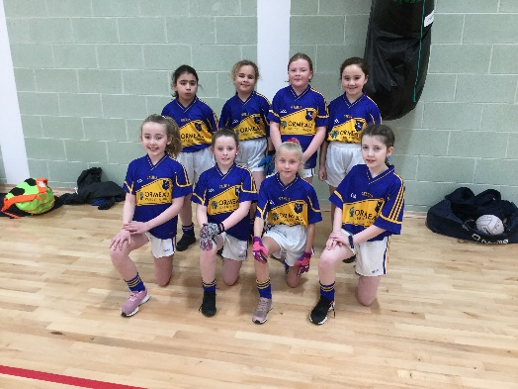

P7 also enjoyed visiting the MAC to see the production of ‘A Christmas Carol’ which is the novel we are studying this term as part of our topic, The Victorians.

P7 girls attended OLSPCK on Friday 13th December They took part in a fun based activity day including Dance, Home Economics and a Netball Tournament.

Homework Survey
Thank-you to all those parents who took the time to respond to our survey about homework in the Summer term. We had 354 responses! We will be reviewing our homework policy this year and will keep you updated about any changes.

Healthy Break
A reminder to parents that in line with our Healthy Break policy, children are only allowed to bring fruit, vegetables, milk and water in to school for their break. Milk can be purchased on a monthly basis. Keep a look out for the letter home to ensure you order it on time.

Wishing you all a very happy and peaceful Christmas!

Reminders
For all the latest school news follow us on twitter @holyrosaryps
Remember no nuts or food made in an environment where nuts are present should be
brought into school. Many thanks.

