Holy Rosary Primary School
September 2018 - Newsletter No.1

Welcome back to all our children and a big thank-you to all our parents for ensuring that their children are so well presented and wearing the correct school uniform. We will be sending out further information about our P.E. uniform shortly. Please note the information below about how to talk to us when you may have a concern about your child in school.

What should I do if I have a concern about my child?
Of course we wish that every child has a happy, successful time in Holy Rosary but if a parent ever has a concern they should make contact with the school as outlined below. The teacher should always be contacted first, then the Key Stage leaders followed by the Principal or Vice-Principal if needed.
- Initially contact the class teacher to talk through the concern. The class teacher should always be the first port of call.

If you feel that you have not been reassured or if you need further clarification or advice……
- Talk to Key Stage Leaders

Foundation Primary - P1 and P2 Ms Clare Ward
Key Stage One - P3 and P4 Mrs Claire McCartan
Key Stage 2 - P5, P6, P7 Mr Louis McVeigh

- If the issue is related to Child Protection contact:
Designated Teacher for Child Protection – Ms Clare Ward
Deputy Designated Teacher for Child Protection - Mrs Carmel Burns

- If the issue is related to Newcomer support contact Mrs Tara Clarke

- If the issue is about Special Needs contact Mrs Carmel Burns

If you feel that the concern has still not been addressed satisfactorily….
- Contact Mrs Carmel Burns (Acting Principal) or the Acting Vice-Principal

Some of these roles may change as the year progresses so we will keep you posted if there are any changes.

We are always here to help so don’t hesitate to ask!
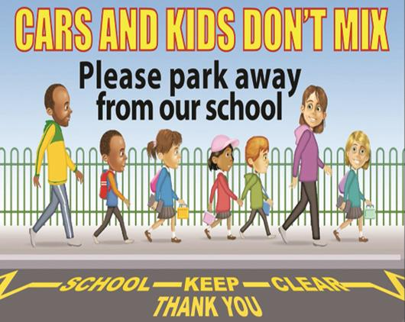
Parking on Sunnyside Crescent
A polite request to parents who drop children off and collect them from school not to park in Sunnyside Crescent. Thank-you to all those members of our school community who put the safety of our children first and co-operate by NOT parking in Sunnyside Crescent before and after school.
Our school is a nut free school. Remember that nuts or products made in an area where nuts are present should not be brought in to school. Some of our children are highly allergic to nuts so this poses a severe threat to their wellbeing. Thank you so much for co-operating in this matter.
Attendance and Punctuality
It is vital that children attend school every day, ‘If you don’t attend you can’t attain’. If your child is unwell and unable to attend on a particular day, please ensure that you contact the school to inform us and that a note explaining the absence is sent in with the child on their return to school.
Being on time for school is equally important. If a child is regularly late they miss a crucial part of the school day and may find it more difficult to settle into class. School starts at 9 am and children can go to class from 8.45 am where they will be supervised by their teacher.
Reminders
For all the latest school news follow us on twitter @holyrosaryps
Our school calendar is updated throughout the year, just visit our website http://holyrosarypsbelfast.com/
Let’s have a wonderful year together.

